**Steven J. McGee Distributed Systems Architect / Patent Applicant / Consultant**

Figure 1: USPTO 13/573,002 Annex K Signals & Telemetry for RBF’s The World Game USPTO 13/573,002 Adaptive Procedural Template Coding programmable $$, Economy Current: Distributed Systems Architect, Patent Applicant – self-employed.

June 2004 – March 2018 Simple Always Wins Concepts LLC SAW Concepts LLC (dissolved)

Defense Contractor for Validity Systems, SAIC x 2, MITRE, BAE Systems 1996 – 2002

Master of Science Information Systems Western International University 3.85 GPA 93 - 96

B.A. Psychology, Business Concentration Indiana University of Pennsylvania 1978 - 1992

United States Army Signal Corps Officer 11 years 82 – 93 / ROTC Full Scholarship Recipient

Presenter: International Conference Complex Systems ICCS New England chapter 2006

June 2003 – Present: Patent applicant USPTO 13/573,002: The Heart Beacon Cycle Time – Space Meter Adaptive Procedural Template (checklist of tools, processes, algorithms, protocols… useful to form Distributed Autonomous Groups DAGS synchronized in time – space Checklist: ideas, algorithms, processes, procedures, metrics, meters, signal & telemetry structured data for consistent Eco sustainable economic time cycle epochs for programmable $ / economy / Net, Net of money foundation technology for DeFi, programmable internet, internet of money.

USPTO 13/573,002: Adaptive Procedural Template foundation tech list for net, net of $, economy. System of systems structured data exchange brevity codes - message sets telemetry syntax lexicon mapped to A.I., IoT symbols for human man-machine interface. Foundation technology for programmable $$$ money is being asserted by Banks / tech firms which are forming teams to assert establishment of foundation technology pursuant to securing IP intellectual property patent claims in DeFi / programmable money.

SCOTUS “Alice in Wonderland” ruling "claims may not direct towards abstract ideas".

Figure 2: USPTO 13/573,002 Net, net of money foundation framework technology

THESIS: All things internet, internet of programmable money are formed using:

1. Time epochs created by oscillating quartz crystal silicon chips

1. Syntax used / not used as programming instructions during epoch time cycles

THESIS SUMMARY: All things internet, net of money blockchains are formed by unicast, multicast, anycast protocols. Programmable money’s improvements are in cryptography. Blockchains are formed by unicast, multicast, anycast and workflow filters.

Programmable money’s improvements are in cryptography. Internet 3.0 and the new web will be based on the original structure described by Stanford University. There are no packets, frames, layers, blocks, shards, graphs, hash graphs “bots”, “motes”, … or Satoshi's traversing the net, stored in a blockchain cube. Transactions are unicast, multicast, or anycast (workflow). The afore mention terms are non-existent fabrication. We need an Eco sustainable Economic Heartbeat with incentives systemically coded into the programmable economy applying consistent time - space metrics, meters and a syntax lexicon library. The German military made a suggestion circa 2003 namely OOTW Operations Other Than War of use of Battlefield Digitization for humanitarian relief, digital dashboards displaying updates to an EIN Earth Intelligence Network drawn from a system of Distributed Autonomous Systems DAO. (RAND term circa 2001)

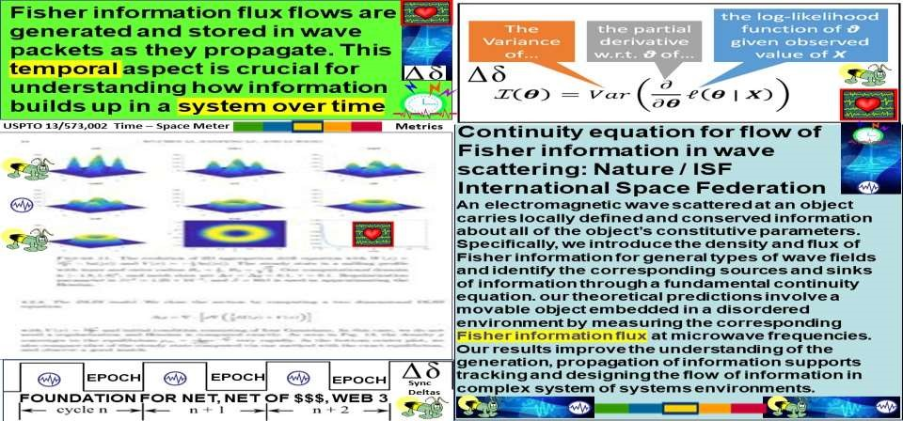

Figure 3: Fisher wave info flux flows / USPTO 13/573,002 quantum Time – Space Meter

Fisher information flux flows are generated and stored in wave packets as they propagate. This temporal aspect is crucial for understanding how information builds up in a system over time. USPTO 13/573,002’s wave water drop in pond meme = description

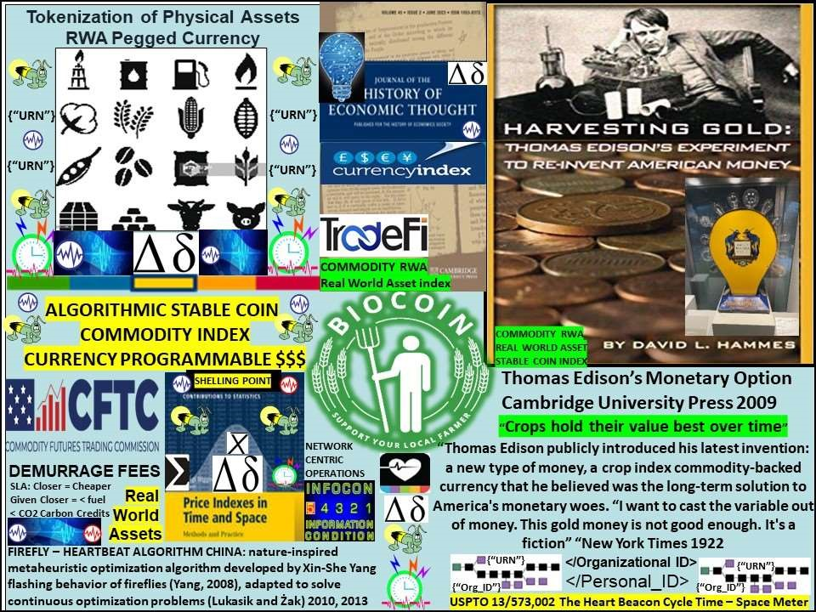

Figure 4: Inventor Thomas Edison’s Monetary Option circa 1921 / Algorithmic stable coin

Fix money = fix world // Foundation Technology for Programmable $$$, Economy, complementary currencies supporting distributed trade organizations Thomas Edison’s Monetary option: Thomas Edison and Henry Ford proposed a currency based on the value of a basket of crop commodities in 1922. Inventor Thomas Edison believed that crops held their value over time. “I want to cast the variable out of money. This gold money is not good enough. It's a fiction” (New York Times 1922). Thomas Edison’s Monetary Option: LINK: <https://www.supermoney.com/2014/06/thomas-edisons-view-money/>

*REFERENCES Beale, W. T. M. Jr., Kennedy, M. T., and Winn, W. J. (1942) Commodity Reserve Currency: A Critique, Journal of Political Economy, 50 (4), pp. 579–94.*

Boyle, David (Ed) (2002) The Money Changers: Currency Reform from Aristotle to Ecash (London: Earthscan).Google Scholar

Clark, J. M. (1933) The Proposal for a Composite Commodity Currency, in: Economic Essays In Honour of Gustav Cassel (London: George Allen & Unwin), pp. 75–87.

Crennan, C. H. (1922) Responses to Questionnaire, February 24, Banking, Box 7, folder 3, West Orange, NJ: Edison National Historic Site Archives.

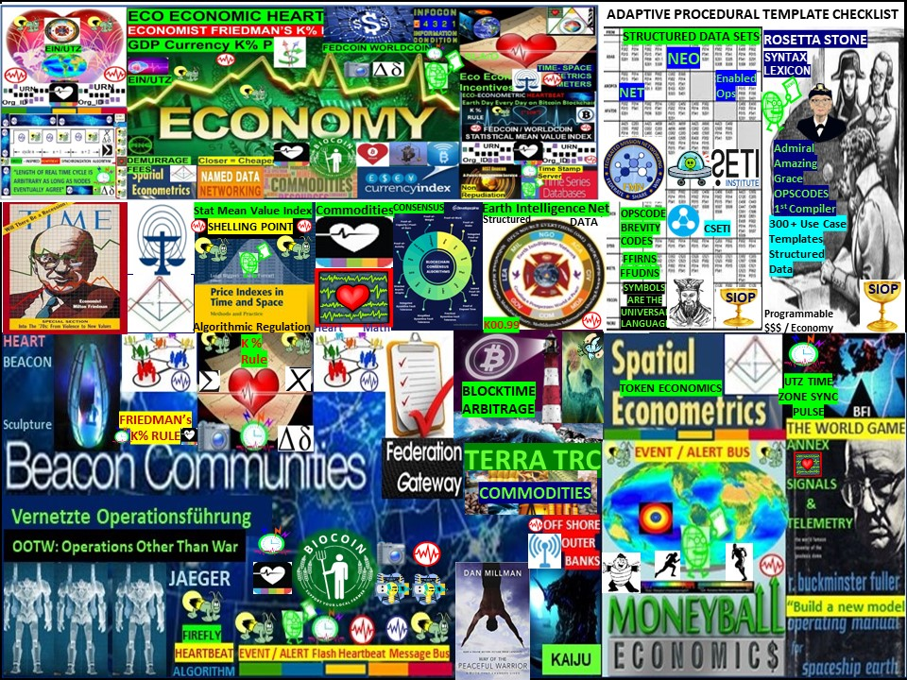

FIGURE 5: Foundation tech formed by Battlefield Digitization OOTW

Battlefield Digitization for OOTW Operations Other Than War: i.e., Eco Economic Epoch

Heartbeat / USPTO 13/573,002 The Heart Beacon Cycle Time - Space Meter Adaptive

Procedural Template paper, use cases, claims, graphics, metrics, meters, syntax lexicon #A.I. Battlefield Digitization consists of structured data where OPSCODE brevity codes are mapped to symbology, symbol sets organized into 300 + Use Case messages . Brevity code mapping to symbols is essential to A.I. Artificial Intelligence man – machine interface

Improvements as the basis of invention to U.S. Army CECOM Communication Electronics Command's "greatest invention" distributed systems dashboard structured data exchange framework as swords to plowshare use cases for economic reset, climate change sustainable development incentives, stable coin Fed-World Coin.

Teams are forming to win the DeFi Distributed Finance / programmable $$$ money IP Intellectual Property wars. The winning team will prove that their IP intellectual property filings established. Foundation tech described through the lens of SCOTUS 2014 "Alice in Wonderland" ruling? "Claims may not direct towards abstract ideas"

SUMMARY: Adaptive Procedural Template Framework: checklist: ideas, algorithms, processes, procedures, metrics, meters, signal & telemetry structured data for consistent epoch time cycle for the net, programmable $ / economy. Foundation Technology for DeFi, structured data syntax – symbol mapping / messaging / economy, quantum computing, AI artificial intelligence. Minimum trade federation consensus checklist i.e., timing - sync schedule, OPSCODE brevity codes, UTZ event stochastic harmonization, consensus algorithm common description, measurements, metrics supporting trade federation (s), support for DAO Distributed Autonomous Organizations, parallel economies e.g., Texas gold backed currency. Web 3.0 USPTO 13/573,002 framework supports for example, Distributed Trade Federation Organizations with DoD / NATO system of systems engineering signaling, telemetry engineering, syntax OPSCODE brevity codes matched to 2525C symbols for A.I. man-machine interface,

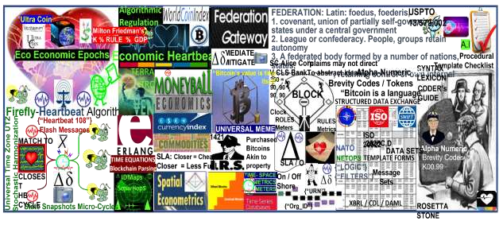

Figure 6: USPTO 13/573,002 is an Adaptive Procedural Template list of tools, systems engineering design, artifacts, agreements, standards supporting complex systems

**USE CASES**

1.Supreme Court **US SC 573 US 134 2347** Alice Corp Vs CLS Bank compliant physical meme i.e., cryptocurrency blockchain DLT programmable money meme

2. Foundation technology for programmable money / economy i.e., Syntax Lexicon

Namespace derived from NATO / DoD brevity OPSCODE FFIRN, FFUDNS structured data exchange mapped to symbols for A.I. Big Data. Establishes a consistent, universal syntax structured data exchange library – lexicon using UTZ time stamping data by organization <Org_ID>. data class type, resource type to form a universal syntax, code, date element </tag> Rosetta Stone given all things internet are formed using 1. time epoch cycles 2. syntax as instructions. Physical is the opposite of abstract. See SCOTUS Alice ruling 2014

3.Distributed Autonomous Organization DAO Trade Federation common signaling, telemetry, symbol, and data element sets forming a foundation technology framework including structured data exchange to assist DAO’s stay synchronized, stochastically harmonized across UTZ zones.

1. Tether, untether to autonomous trade federations using agile, adhoc NetOps as an option to formal merger, acquisition. Support federations: from Latin: foedus, gen.:

foederis, covenant characterized by a union of partially self-governing states or regions under a central government.

1. Micro to macro-cycle system of systems data updates at agreed upon times observing agreed durations i.e., stock, commodity, currency trade epochs. Discrete time interval start, stop, TTL Time To Live trade windows commands embedded in </108> heartbeats, heartbeat messages.
2. Algorithmic regulation: firefly inspired heartbeat synchronization algorithm in stocks, currency exchanges is a segue to algorithmic regulation. Improving temporal trade parity between Bitcoin Blockchain & conventional stock exchanges by using the fireflyheartbeat algorithm to sample events among trader populations across time zones to establish consensus among disparate trade protocols, optimal trade speed / frequency.
3. The "Grail" A sync'd shared situational awareness view derived from filtering, prioritizing events drawn from a system of systems universal heartbeat message event bus sync delta epoch updates Universal Time Zone UTZ proposal using via improvement to the University of Bologna / Hungary’s firefly inspired heartbeat synchronization algorithm by matching the firefly synchronization pulse to the closest OPTEMPO cycle.
4. Support economist Milton Friedman’s K% rule where a CBDC, federal, world currency is derived from sampling lead GDP economic indicators across a global event message bus sync delta changes updating a RWA Real World Asset based commodity index currency.
5. Ecologically sustainable economic epoch time cycles to measure, meter sync delta cyclic changes describes linear sequential, geo-spatial temporal intensity radius hop count econometric metrics, meters where closer is shorter, closer is cheaper, less CO2
6. Data over wired, wireless power lines SLA service level agreement where closer = cheaper given closer involves maintenance of electrical, data equipment infrastructure

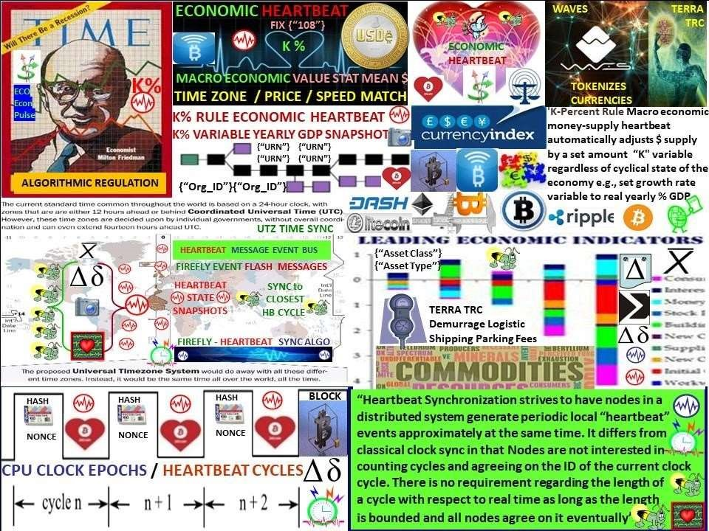

**Figure 7: Nobel Prize Winning Economist’s K% rule / USPTO 13/573,002**

The K-Percent Rule was a proposal by economist Milton Friedman that the central bank should increase the money supply by a constant percentage every year. The K-Percent Rule was a proposal by economist Milton Friedman that the central bank should increase the money supply by a constant percentage every year. The K-Percent Rule proposes to set the money supply growth at a rate equal to the growth of gross domestic product (GDP) each year. In the United States, this would typically be in the range of 2-4%, based on historical averages. The K-percent rule, proposed by economist and Nobel Prize winner Milton Friedman Milton Friedman Milton Friedman was an American economist who advocated for free market capitalism. Friedman's freemarket theories influenced economic, is a monetary policy rule that requires central banks to increase the money supply irrespective of the condition of the economy. Supporting economist Milton Friedman’s K% rule where a “FEDCOIN / WORLDCOIN currency could be derived from sampling lead economic indicators across a global, universal event bus applying the firefly-heartbeat algorithm tracking changes, updating a GDP commodity statistical mean value index of GDP Real World Assets RWA.

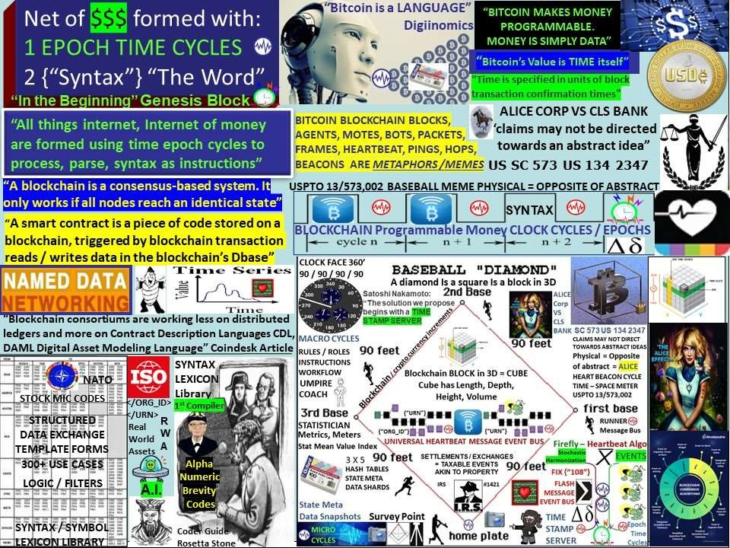

**FIG 8 SCOTUS Alice Corp Vs CLS Bank “claims may not direct towards abstract ideas”**

***Alice Corp. v. CLS Bank International***, 573 U.S. 208 (2014), was a 2014 [United States Supreme Cou](https://en.wikipedia.org/wiki/United_States_Supreme_Court)[rt[1] d](https://en.wikipedia.org/wiki/Alice_Corp._v._CLS_Bank_International#cite_note-1)ecision about [patent eligibilit](https://en.wikipedia.org/wiki/Patent_eligibility)[y.[2] T](https://en.wikipedia.org/wiki/Alice_Corp._v._CLS_Bank_International#cite_note-2)he issue in the case was whether certain patent claims for a computer-implemented, electronic [escrow s](https://en.wikipedia.org/wiki/Escrow)ervice covered [abstract ideas,](https://en.wikipedia.org/wiki/Patentable_subject_matter) which would make the claims ineligible for patent protection. The patents were held to be invalid because the claims were drawn to an abstract idea, and implementing those claims on a computer was not enough to transform that abstract idea into [patentable subject matter.](https://en.wikipedia.org/wiki/Patentable_subject_matter#United_States)Ruling “claims may not direct towards abstract ideas”. Physical (baseball meme) is the opposite of abstract”

Although the *Alice* opinion did not mention software as such, the case was widely considered as a decision on software patents or patents on software for business methods.[[3](https://en.wikipedia.org/wiki/Alice_Corp._v._CLS_Bank_International#cite_note-3)[][4]](https://en.wikipedia.org/wiki/Alice_Corp._v._CLS_Bank_International#cite_note-4) *Alice* and the 2010 Supreme Court decision of [*Bilski v. Kappos*,](https://en.wikipedia.org/wiki/Bilski_v._Kappos) another case involving software for a business method (which also did not opine on software as such[[5])](https://en.wikipedia.org/wiki/Alice_Corp._v._CLS_Bank_International#cite_note-5), were the most recent Supreme Court cases on the patent eligibility of softwarerelated inventions since [*Diamond v. Diehr*](https://en.wikipedia.org/wiki/Diamond_v._Diehr) in 1981.[[6]](https://en.wikipedia.org/wiki/Alice_Corp._v._CLS_Bank_International#cite_note-6)

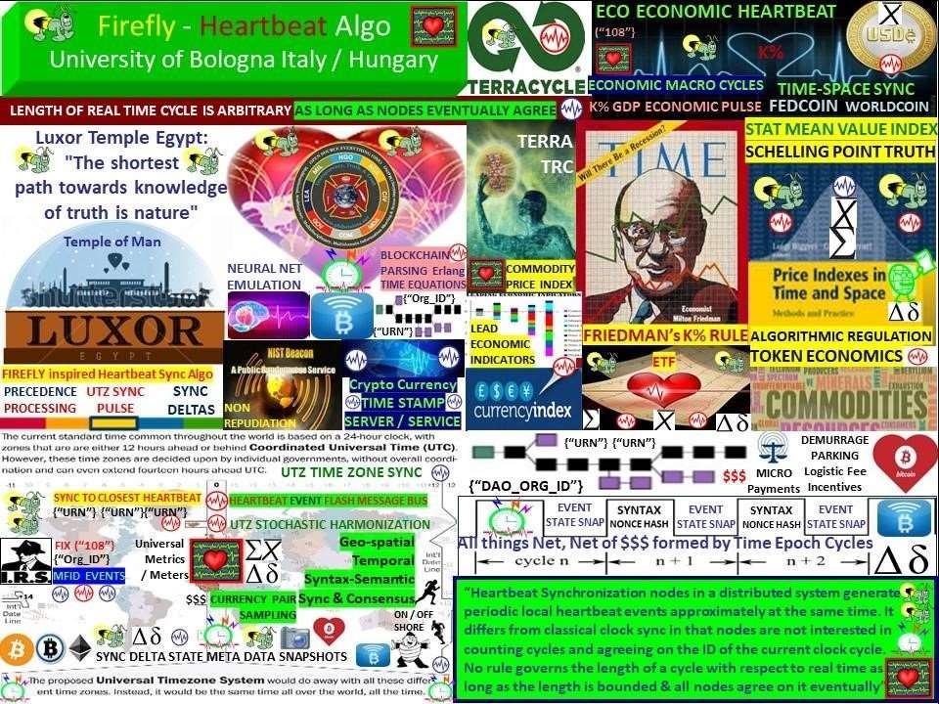

**FIGURE 9: FIREFLY HEARTBEAT SYNCHRONIZATION / World Economic Heartbeat**

Firefly inspired Heartbeat Synchronization: in a paper entitled Firefly-inspired

Heartbeat Synchronization in Overlay Networks by the University of Bologna Trento Italy along with the University of Szeged, Hungary: “Heartbeat synchronization strives to have nodes in a distributed system generate periodic, local “heartbeat” events approximately at the same time. The heartbeat synchronization protocol for overlay networks is inspired by mathematical models of flash synchronization in certain species of fire flies. Nodes send flash messages to their neighbors when a local heartbeat triggers. Fireflies adjust the phase of their next heartbeat based on incoming flash messages using an algorithm inspired by mathematical models of fire-fly synchronization. Heartbeat synchronization strives to have nodes in a distributed system generate periodic, local “heartbeat” events approximately at the same time. It differs from classical clock synchronization in that nodes are not interested in counting cycles and agreeing on a ID of a current cycle. There is no requirement regarding the length of a cycle with respect to real time as long as a length is bounded, and all nodes agree on it eventually.

**Use Case:** Economic Reset solution: form economic trade federations incentivizing environment friendly business practices leveraging Bitcoin's micro-payment capabilities supporting the TERRA Trade Reference Currency TRC demurrage handling charge. Closer is cheaper, less fuel, < C02 carbon emission in smart contract Service Level Agreements.

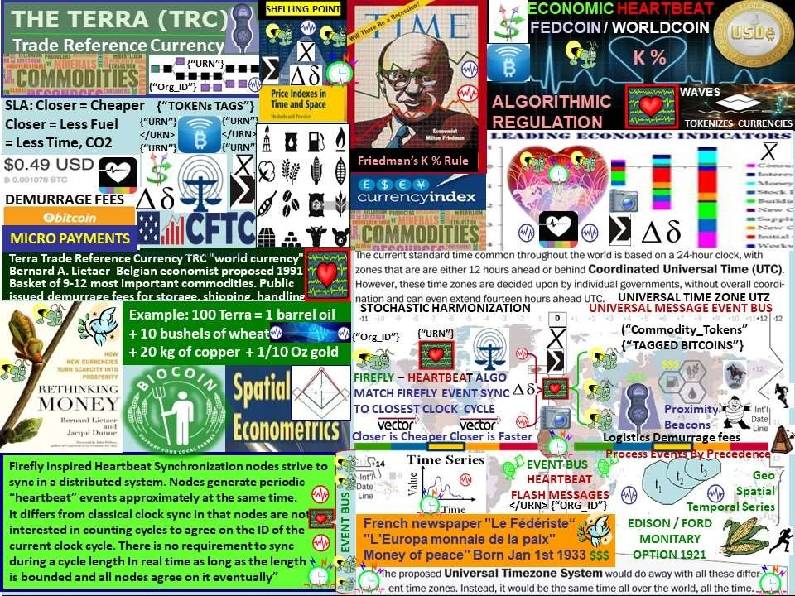

**FIGURE 10: TERRA Trade Reference Currency / Crypto micro payment Demurrage fees**

Nobel Prize winning Economist Milton Friedman’s K% rule is what I call an “economic heartbeat” K-Percent Rule. DEFINITION of ‘K-Percent Rule’. The K-Percent Rule was a proposal by economist Milton Friedman that the central bank should increase the money supply by a constant percentage every year. The K-Percent Rule proposes to set the money supply growth at a rate equal to the growth of real GDP each year. K-Percent Rule —  Investopedia<http://www.investopedia.com/terms/k/k-percent-rule.asp>

Cu;rrency / Economic [RESET i](https://twitter.com/hashtag/RESET?src=hash)s a mathematical certainty. Do we [RESET t](https://twitter.com/hashtag/RESET?src=hash)he global system of systems as is or re-engineer our world using NATO / DOD system of systems engineering framework standing on the shoulders of giants swords to plowshares ?

**IF climate change causes a drop in crop commodity by 20–25 % while population grows,**  **THEN this condition will become a matter of national security. THEN this will require revisiting Belgian Economist Bernard Lietaer’s TRC Trade Reference Currency ELSE face chaos by not leveraging proven system of systems, procedures, processes, tactics, etc..**



**Figure 11: Nobel Prize Winning Economist Milton Friedman’s K % GDP based rule**

**Economist Milton Friedman predicted the rise of a computer capable of automatically adjusting the inflation rate of money. This is precisely what we see in the case of bitcoin, as a regulatory algorithm intelligently adjusts the mining difficulty to make the issuance of blocks more or less easy depending on the demand for network hashing power. No money system we have seen to date can claim it is chronologically regulated. The universal construct of time is the backbone of the cryptocurrency digital economy. Investopedia K % Rule** [Source**:**](https://www.investopedia.com/terms/k/k-percent-rule.asp) [**https://investopedia.com/terms/k/k-percent-rule.asp**](https://investopedia.com/terms/k/k-percent-rule.asp)

Satoshi Nakamoto’s Bitcoin key building block is a time stamp server. "Bitcoin is intended to be paired with the market place" "the blockchain stores references to market indexes"

**Demurrage: term used in currency trading to denote cost of currency ownership and/or storage. cost of carrying money… considered superior to interest payments, as it stimulates currency circulation and economic growth. “In a physical sense, demurrage represents a delay that occurs during the transportation of goods via truck. When this happens, the trucking firm delivering the product can opt to pay a flat fee to the receiver to cover any loss incurred as a result of the delay. This fee can be assessed on an hourly basis. Or in the case of gold, demurrage is simply the costs associated with storage of bouillon.** [**LINK https://investopedia.com/terms/d/demurrage.asp**](https://investopedia.com/terms/d/demurrage.asp)

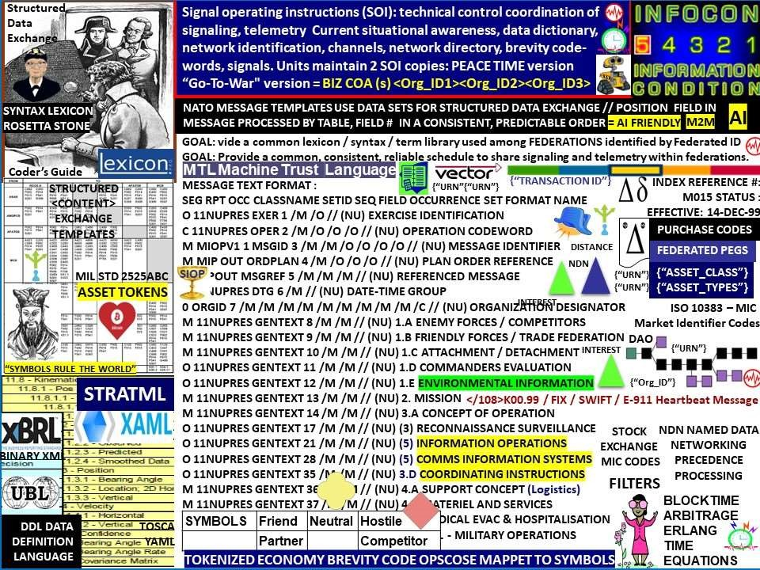

Fig 12: Syntax Lexicon Library Rosetta Stone from DoD / NATO system of systems framework

Common syntax library of various Message Text Formats MTF to enable universal signaling / telemetry among a system of systems is ESSENTIAL. Decades of research at the taxpayer's expense into structured messaging / structured data exchange where the location, type of data identified by table number will help accelerate the process of organizing syntax into categories from disparate systems into data set reference repositories. Many semantic, syntax tags will be reusable. The rules, roles and logic developed by years of research involving thousands of subject matter experts solving real world issues is the value to be extracted from 300+ message sets. NATO stays synchronized across many languages and cultures so why reinvent the wheel?

MESSAGE CATALOG: The USMTF message library has over 300 messages to choose from to facilitate information exchange requirements. MTFs presenting data in a logical, well specified and unambiguous layout. MTFs are transmission medium neutral. The content of the Message Catalogue has been developed by military operators over the last 20 years. Messages are regularly maintained to keep pace with the latest tactics and doctrine. **Military brevity codes and stock exchange codes are similar. security Identifier used in financial markets are: SYMBOL,**

**CUSIP, ISIN, SEDOL, RIC Code,** Syntax Lexicon Library

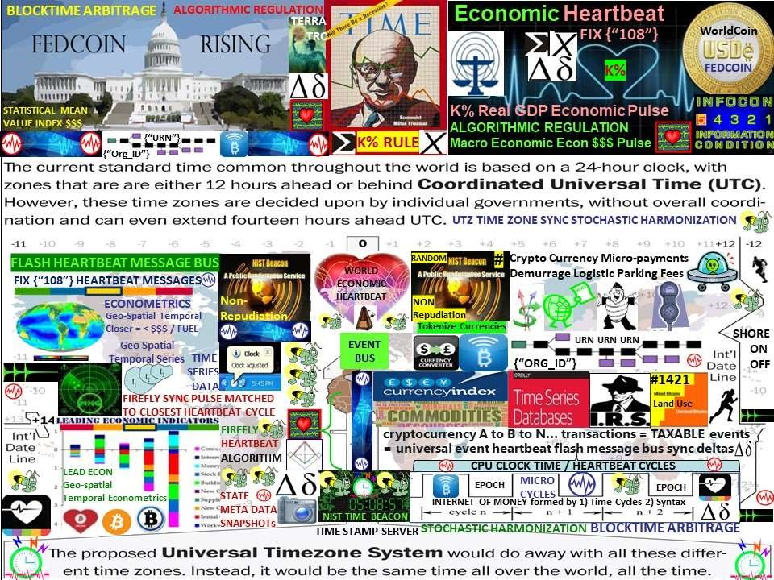

# Figure 13: FEDCOIN / WORLD COIN Synchronization / stochastic harmonization

One world currency for the one world government requires financial events stochastically synchronized, harmonized across the world's time zones and will will represent a value index of the world's GDP Gross Domestic Product RWA real world asset commodities.

"The economy of imaginary wealth is being inevitably replaced by the economy of real and hard assets'' President Vladamir Putin **Closer is cheaper, < fuel, less C02 carbon**

The world’s system of systems needs to be time-space synchronized, stochastically harmonized across the one world, global UTZ Universal Time Zone via heartbeat messages using universally shared, standards based OPSCODE brevity codes drawn from a universal structured data exchange syntax lexicon with over 300 use case templates

e.g., NATO’s lexicon library.Universal Time Zone UTZ proposal using via improvement to the University of Bologna / Hungary’s firefly inspired heartbeat synchronization algorithm by matching the firefly synchronization pulse to the closest OPTEMPO sync cycle.

**SOCIAL MEDIA / DOCUMENTS / GRAPHICS**

Linked IN: https://www.linkedin.com/in/ecoeconepochs/

FACEBOOK: https://www.facebook.com/beaconheart

Github: <http://github.com/Beacon-Heart>

IPFS Interplanetary File System Web3 web page. <https://ecoeconomicepochs.dao/>

SCRIBD Documents: <https://www.scribd.com/user/11781571/Steven-James-McGee>

Slideshare Files: <https://www.slideshare.net/EcoEconomicHeartbeat>

X / Twitter: https://twitter.com/Heart_Beacon

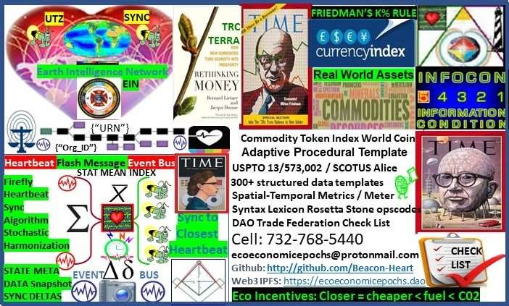

Figure 14: Steven “FutureMan” McGee’s Business Card / Contact Information

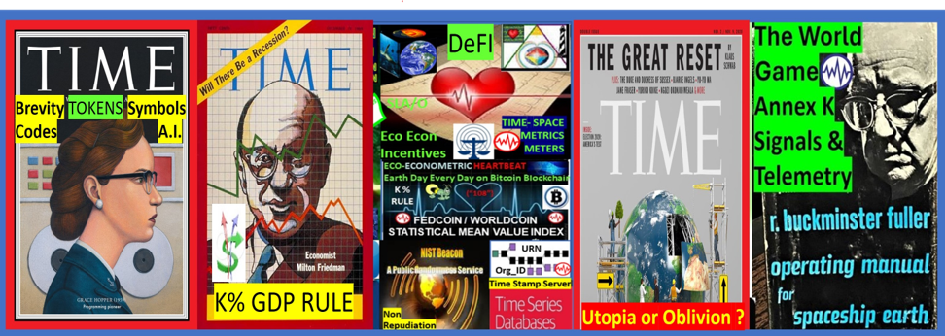

**Buckminster Fuller's The World Game: Utopia or Oblivion ?**

**Swords to plowshares solutions. Nobel Prize winning Economist Milton Friedman "only a crisis real or imagined brings change and makes the politically impossible the politically inevitable"**

**GitHub:** [**http://github.com/Beacon-Heart**](http://github.com/Beacon-Heart)

